Decision Constructs



Block :

{

// group of statements

<< Statements >>

}

If (Boolean expression )

{

<<statements >>}

}

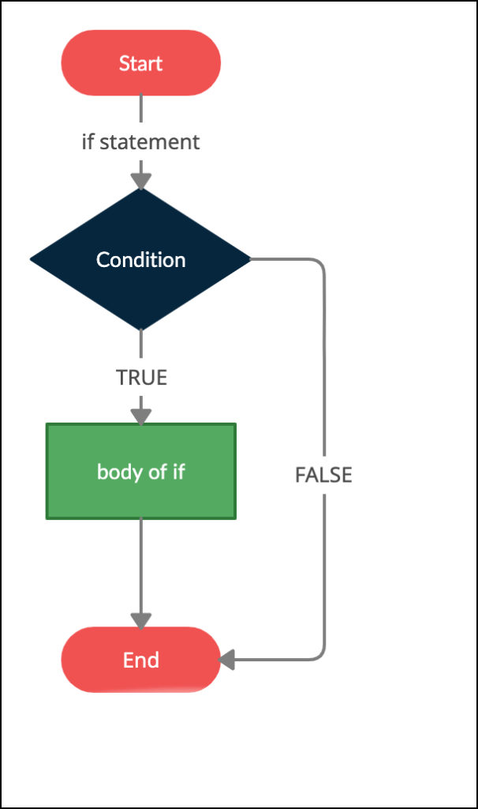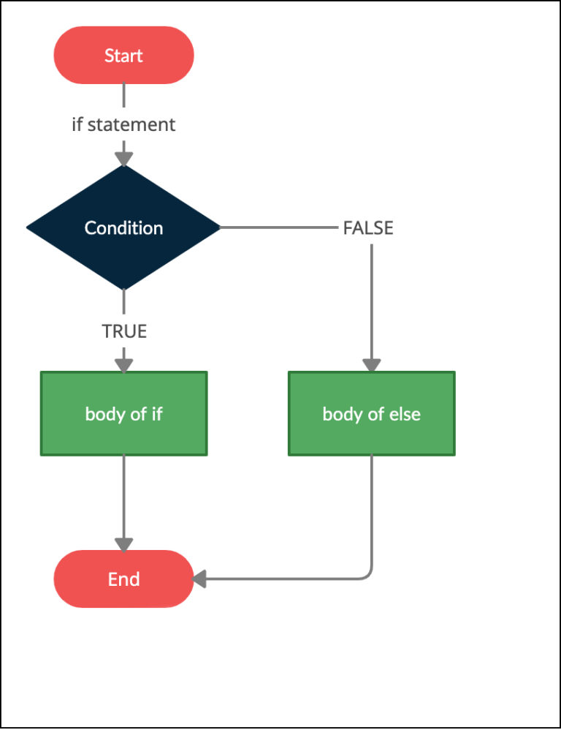

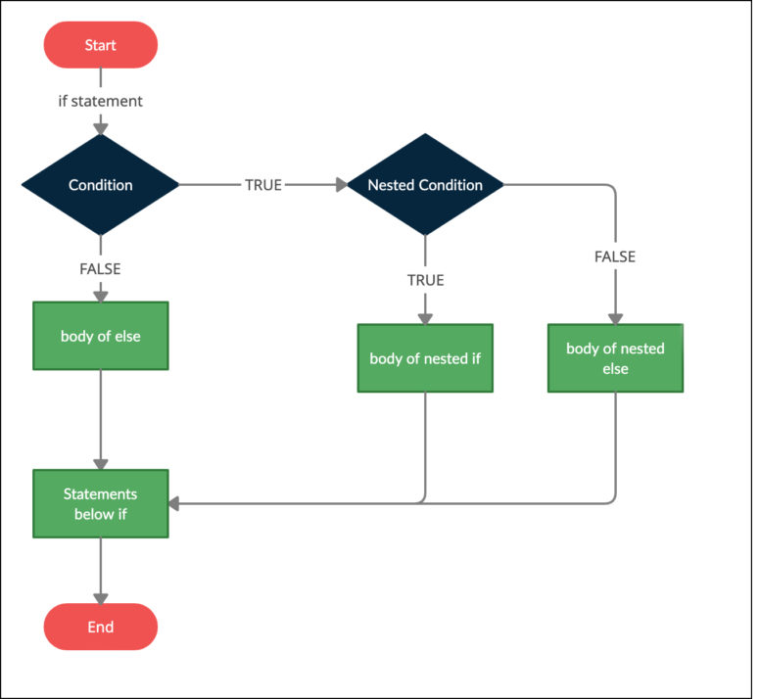

Nested IF

It is an if statement that is target of another

If or else .

It is very common in programming

Whenever working with nested if else , else statement always refers to nearest if statement



If else if ladder :

If (Condition )

Statements ;

Else if (Condition)

Statements ;

Else if (Condition)

Statements ;

…..

….

Else

Statement



Other Alternative of if else ladder is switch case

When a value requires different actions (winter ,summer , spring ,autumn) for a fixed set of values (1 to 12 ) . if else case get more complex . In order to reduce complexity and increase readability we use switch statement. And only one case will be executed among all the available cases

Switch (a)

{

Case 1:

Season =winter;

}

Goal :

To push code from local to remote repository

Steps : Navigate to folder containing files to be pushed to remote repository

Git init ( to keep a track on files for changes )

git config --global user.email "vidyashekar.kammari@gmail.com"

git config --global user.name "vidya.shekar"

Git status ( gives a list of added , deleted and modified files )

Git add name_of_ the_file ( adds to stagging area )

Git commit -m “meaningful message”

Git remote add origin “git hub repository url” (first time)

Git push -u origin master ( first time )

Git push (second time onwards)

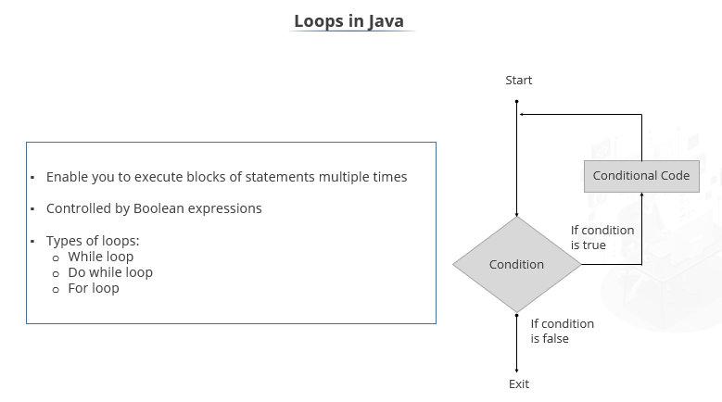

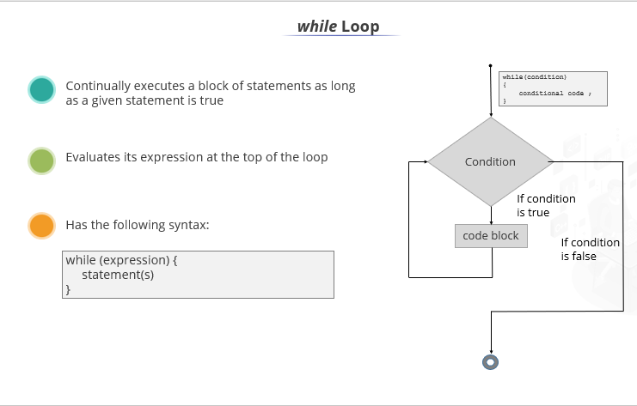

For Loop :

2 forms in for loop

Traditional form

For each

Continue: Does not break the loop ,

But it skips steps in the loop it means it stops the current steps of the loop and moves to next iteration

Dynamic Initialization :

It allows variable to be initialized dynamically , using an expression









Any real world entity will have state and behaviour

State = data

Car :

Color

Model

Engine

Student

Sno , dob , email , mobile –

Emp :

Eno , ename , depot , loc –

State : represents data of an object

Behaviour : operations performed n object / functionality

Bank : ifscode , brand name , location

Behaviour : deposit , withdraw , transaction history , credit card payment

Object : state , behaviour ,

Its an instance of a class

Class : new data type , using it we can create objects of that type

Template to create an object

3 types of variables

Local variable – method --

These are declared inside method and scope of variable is inside the method

Instance variables -- every object will have a copy of instance variable

These are non static

They are declared inside the class but outside the methods

Class variable / Static variable





Method : method is a collection of statements grouped together to perform an operator / task

